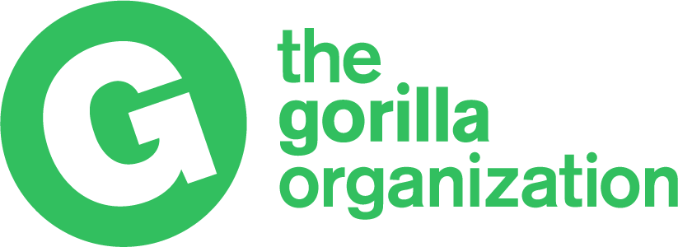

London Marathon 2026 | Participant Application Form

To apply for one of The Gorilla Organization’s Golden Bond places, please complete all sections of this form as fully as possible.

Medical Conditions
If you have a medical condition that could be adversely affected by exercise, particularly a heart condition, or if you have any doubts about your health, please consult your doctor before submitting your application.

How much do I have to raise?
The minimum sponsorship commitment to receive a Gold Bond place with the Gorilla Organization is £3000. This includes a non-refundable £200 deposit, entry to the 2026 London Marathon, a running shirt with your name on and support from your dedicated charity rep.

Personal Details

Name and Title:

Full Address and Postcode:

Daytime contact phone number:

Email:

Date of Birth:

Occupation:

Are you an existing Gorilla Organization supporter: Yes No

I would like to be kept informed on The Gorilla Organization’s news, events and campaigns:

By Post By Email

Running Experience

How would you describe yourself?

Fun Runner Regular Runner Club Runner

Have you run a Marathon before? Yes No

Please give details:

Did you apply for the online public ballot? Yes No

Training Schedule

When will you start training?

Do you have a training schedule? Yes No

Would you like further information on training? Yes No

What time do you expect to achieve?
(This won’t affect your application)
Marathon Sponsorship

Have you previously engaged in any other fundraising activities for charity? If so, please provide details and indicate how much you raised:

Why do you want to run for The Gorilla Organization?

Our runners must raise at least £3000, which includes a £200 upfront registration fee upon successful application. We allocate places based on the strength of applications, as there is always significant interest but limited places available. Therefore, please let us know why you want to run for us and what fundraising ideas you have planned to meet and exceed your target. Application forms received without a fundraising plan will not be considered.

How will you raise the sponsorship?

Fundraising Idea:

Estimated Target £
Fundraising Idea:

Estimated Target £
Fundraising Idea:

Estimated Target £
Fundraising Idea:

Estimated Target £

Total Estimated Target £

Does your company offer a matched giving scheme? Yes No Not sure

Name of company:

Many companies will match pound-for-pound donations made to registered charities by their employees. It’s worth checking with your HR department to see if your company operates a similar scheme.

How did you hear about our Golden Bond places for the London Marathon?

The Gorilla Organization Website Social Media

London Marathon Website Other

If other, please give details below:

I understand that photographs may be taken during the event which may be used to publicise future events and the work of the charity generally.

I am happy for The Gorilla Organization to use my image: Yes No

Runner’s Declaration

By signing the declaration below, I confirm that I will be 18 years or over on Sunday 26 April
2026 and that I am pledging to raise a minimum amount of £2,800 for The Gorilla Organization. I agree to make up the shortfall myself to the required minimum £2,800 should I not reach my fundraising target.

All sponsor money raised represents a vital contribution to The Gorilla Organization’s aim to save Gorillas from extinction in the wild and will be used to fund projects most needed to accomplish this.

Signed: Print Name: Date:

Please return your completed application form to:
The Gorilla Organization, London Marathon 2026, 110 Gloucester Avenue, London NW1 8HX
Or scan a completed copy to sophie@gorillas.org

We will respond to your application as soon as possible. In the meantime, if you have any queries about running the Marathon for The Gorilla Organization please contact us on 0207 916 4974 or email sophie@gorillas.org

THANK YOU FOR YOUR APPLICATION

